Annual Conference
Grantmakers for Education 2026 will be held October 13-15, 2026 in New York City. Preconference activities are scheduled for the 12th. Registration opens Summer 2026, details TBD. The conference provides learning and networking experiences that are highly engaging, showcases innovative ideas, highlights diverse perspectives and focuses on impact. The conference is designed by and for education funders.
The 2025 annual conference was the Grantmakers’ 30th anniversary and was held in Memphis, TN on October 20th. The previous conference’s website is still up and provides details on the agenda, registration, and sponsorship. Nonmembers can register for $2,350. The conference agenda in 2025 included site visits to schools and museums, networking meals, plenary and concurrent sessions, learning sessions and deep dives into specific topics, social parties and happy hour, and yoga. The 2025 sponsorship prospectus provides few details, but claims the conference hosts 800 attendees. Sponsorship opportunities ranged from $100k to $5,000.
See their policy on registration:
Eligibility to Attend
Staff and trustees from grantmaking organizations are eligible to attend. This includes representatives from independent foundations, charitable trusts, community foundations, corporate foundations, charitable businesses, giving programs, private family foundations and public agencies. Individual donors that meet our membership criteria are also eligible to attend.
To support our solicitation-free learning environment policy (below), we ask that those whose sole responsibility is development or fundraising not attend.
Every registration goes through an approval process; once you have completed the registration form, you will receive confirmation typically within 1-2 business days. Confirmation can take up to a week in instances where we may need additional information from you.
We encourage membership-eligible nonmember organizations to become members to receive discounted registration as well as other benefits.

About
Grantmakers for Education (EdFunders) is the largest network in education philanthropy. It brings together grantmaking organizations committed to improving educational outcomes and expanding opportunities for learners at all stages, from early childhood through higher education. The organization functions as a platform for professional learning, peer collaboration, shared research, and strategic influence across the field of education philanthropy.
Guiding Principles:

- Unite for equity and justice
- Inspire breakthroughs
- Act as a compass
- Support united action
- Champion the cause

Vision and Mission
Our vision is for all learners to thrive in education systems that are equitable and just, supported by funders who are equipped with the knowledge and connections to advance transformation.
Grantmakers for Education catalyzes learning, fosters connections and creates opportunities for members to collectively advance effective, strategic and equity-centered grantmaking in the field of education.

Members
Member Organizations
The EdFunders network includes nearly 300 member organizations and approximately 1,400 individual members from foundations and philanthropic entities across the nation. Members range from private, corporate, and community foundations to public philanthropies and education grantmaking entities.
Members gain insider access to emerging trends, amplify their investments, and forge meaningful connections that elevate both individual careers and collective impact. Membership is open to grantmaking entities that provide charitable support to causes across the education spectrum.
Member benefits:

- Peer connections and networks
- Shared insight and collaboration
- Leadership and field influence
- Professional learning and development
- Special access to programs and resources
- Savings and discounts

Impact Groups
EdFunders impact and learning groups are communities where members with common interests can connect with others working on the same issue, learn from experts, and explore opportunities for collaboration. They often serve as incubators for specific issues in education and grantmaking. Current groups include:

- Arts Education
- Equity & Grantmaking
- Learning, Evaluation and Data
- Out-of-School Time
- Playful Learning
- Postsecondary Access and Attainment

Leadership

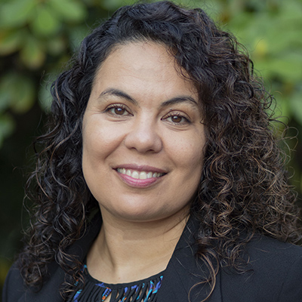
Nicole Rodriguez Leach
Executive Director
As executive director, Nicole leads the organization’s strategy and operations to advance the organization’s vision, mission and guiding principles. She partners closely with the board of directors, funders, and partners across the education and philanthropy ecosystems to address foundational inequities in education, inspire creative thinking in education philanthropy, support collective action and advance positive change to better meet learners’ needs.
Over Nicole’s career, she has seeded and strengthened education sites and systems to foster thriving communities with and for children, youth and families. She has held positions in K-12 and postsecondary classrooms, in community-based and other nonprofit organizations and in the private sector. Her research focuses on education policy, restorative philanthropy, civic engagement and justice in public administration.
In philanthropy, Nicole served as vice president and head of education with Deutsche Bank Americas Foundation and as a program officer with the Stella and Charles Guttman Foundation. Her leadership in the sector extended to chairing donor collaboratives, advising giving organizations and curating learning programs through partnerships with local funding networks. Her grantmaking intricately and purposefully supported programs, policies and partnerships that promote the public promise of education in a multiracial democracy.
Nicole earned a bachelor’s degree in socio-cultural anthropology from Wesleyan University and a master’s degree in urban policy analysis and management from The New School. She is currently a Ph.D. candidate at The Ohio State University.

